**Project Report On**



GREEN-BASKET

Submitted in partial fulfillment for the award of

**Diploma in Advance Computing(E-DAC) from C-DAC, ACTS (Pune)**

**Guided by:**

**Mr. Shakir Hussain**

# Presented by:

**Mr. Ankush Dharkar PRN Number 210540181062**

**Mr. Ankit Gahukar PRN Number 210540181070 Mr. Sameesh Yadav PRN Number 210540181233 Mr. Suyash Varma PRN Number 210540181209 Mr. Akshay Nandanvar PRN Number 210540181015**

**Centre for Development of Advanced Computing (C-DAC), Pune**



**ACKNOWLEDGEMENT**

## This project “**GREEN-BASKET**” was a great learning experience for us and we are submitting this work to Advanced Computing Training School (CDAC ACTS).

We are very glad to mention the name of *Mr. Shakir Hussain* for his valuable guidance to work on this project. His guidance and support helped me to overcome various obstacles and intricacies during the course of project work.

We are highly grateful to Ms. Risha P.R. (Manager (ACTS training Centre), C-DAC, for her guidance and support whenever necessary while doing this course Diploma in *Advanced Computing (E-DAC)* through C-DAC ACTS, Pune.

Our heartfelt thanks goes to *Ms. Swati Salunke* (Course Coordinator, E-*DAC*) who gave all the required support and kind coordination to provide all the necessities and extra hours to complete the project and throughout the course up to the last day here in C-DAC ACTS, Pune.

**From:**

Mr. Ankush Dharkar PRN Number 210540181062

Mr. Ankit Gahukar PRN Number 210540181070 Mr. Sameesh Yadav PRN Number 210540181233 Mr. Suyash Varma PRN Number 210540181209 Mr. Akshay Nandanvar PRN Number 210540181015

### TABLE OF CONTENTS

1. Introduction of Project
2. Product Overview and Summary
   1. Purpose
   2. Scope
   3. Overview
   4. Feasibility Study
3. Overall Description
   1. Product Feature
   2. Technology Used
   3. User Classes

3.3 General Constraints

1. Requirement
   1. Functional Requirements
   2. User Interface Requirements
2. Design
   1. High Level Design
   2. Database Design
3. Interface (UI)
4. Test Report
5. Future Scope

### Introduction of Project:

We have created an online website called Green-Basket where the Customer can buy different types of Vegetables, Fruits and Sprouts.

The platform displays and provides vegetables, Fruits and Sprouts as in whole and category wise to purchase for end Customer. User Interface, developed in React uses Customer email to authenticate and data is imported using REST. UI makes secure calls to Spring Boot. In the backend, JAVA is used to fetch and manipulate the data and used MySQL as database.

The Green-Basket is an application that allows customers to buy varieties of vegetables, Fruits and Sprouts. Green-Basket website provides facilities for adding, deleting, updating products. Admin will manage the category, product line and customers. Once the order is confirmed, product will be delivered to the customer.

For all this a lot of API’s is used for the ease of user. API allows two applications to talk to each other and then the application interprets that data and presents the customer with the information the user wanted in a readable way.

For the login of users into this website we use the customer email authentication, which allows customer to sign up with their email. This platform is based on REST services and it tends to independency of all services. This platform is rapid and frequent due to this technique.

### Product Overview and Summary

* 1. **Purpose:**

We need an e-Commerce website where user can buy different types of FnV items such as Vegetables, Fruits and Sprouts. There are some websites with same business which sell this items so in order to provide service to the customers in this pandemic situation we have created this website so that customers can get more platforms to purchase the FnV Items. We are providing various varieties of Vegetables, Fruits and Sprouts to the customer and also providing user friendly UI to the customer which will help in maintaining the relationship of customer with the company.

### Scope:

GREEN BASKET is a platform where customer can explore the varieties of Vegetables, Fruits and Sprouts and can buy any of them according to their preferences.

### Overview:

Section 3.0, the Overall Description, provides an overview of the components and the relationship between them. Section 4.0 provides the Specific Requirements of the product. In the subsection (4.1) and (4.2) of which the various functional requirements and various interface respectively are discussed. Section 5.0 describes Database Design details.

### Feasibility Study

Feasibility is determination of whether a projects worth doing or not. Before actually recommending the new system it is important to investigate if it is feasible to develop the new system.

Before developing and implementing a system we have sure that our system is feasible in the following ways:

### Technical Feasibility.

1. **Operational Feasibility.**

* **Technical Feasibility**

In the type of feasibility study, the system analyst has to check whether it is possible or not to develop the requested system with availability of manpower, software, hardware, etc. The system which we run in Linux as well as windows platform and hence are suitable for the end- user. The system is technically feasible because it does not require too many resources and runs with the browser. A proof of concept was implemented to verify the technical feasibility to retrieve data from various APIs.

### Operational Feasibility:

In this type of feasibility study the operation implementation of the system is considered. Checking is done regarding whether it is feasible for the users to use the application. Thus the proposed system is said to be operationally feasible only of the end users are able to understand the system clearly and correctly and can use the system with ease and with the minimum training.

### Overall Description:

* 1. **Product Features**

The project's aim is to provide an e-Commerce website for online selling of vegetables, fruits and sprouts which is containing java (platform independent), React, API’s for user

### Technology Used BACK END

Spring Boot with Rest-API

MYSQL for storage of data.

### FRONT END

React

Bootstrap/Material-ui

REDUX

Platform:

Web Development: J2EE Spring Boot, React, MySQL J2EE Spring Boot

Spring Boot has been built for Rapid Application Development. The goal of Spring Boot is to

provide a way to create Java applications quickly and simply, through an embedded server. By default, it used an embedded version of Tomcat and hence eliminating the need of Java EE containers.

It is a framework to ease the bootstrapping and development of new Spring Applications. Bootstrapping with defaults included in the configuration/ jar-dependencies. Easy to create standalone applications with embedded Tomcat/Jetty/Undertow. It provides defaults for code and annotation configuration to quick start new spring projects within no time. Plenty of Spring Boot Starter to quickly get up and running.

No code generation and no requirement for XML configuration. It reduces lots of development time and increases productivity.

React

React is a JavaScript library for building user interfaces. It has transformed the way we think about front-end development. React.js has clasped the engagement of the open-source community. And its demand is irreversible in the coming future. It is here to stay.

Improved performance: React uses Virtual DOM, thereby creating web applications faster. Virtual DOM compares the components’ previous states and updates only the items in the Real DOM that were changed, instead of updating all of the components again, as conventional web applications do.

MySQL

MySQL is an open-source relational database management system (RDBMS).A list of commonly used MySQL queries to create database, use database, create table, insert record, update record, delete record, select record, truncate table and drop table etc. MySQL is a relational database management system based on SQL – Structured Query Language. The application is used for a wide range of purposes, including data warehousing, e-commerce, and logging applications.

The most common use for MySQL, however, is for the purpose of a web database. It can be used to store anything from a single record of information to an entire inventory of available products for an online store. In association with a scripting language such as PHP or Perl (both offered on our hosting accounts) it is possible to create websites which will interact in real- time with a MySQL database to rapidly display categorized and searchable information to a website user.

### Users

There is three type of user which can access this website. Customer, Delivery Boy and one is ADMIN which will manage the users, products and orders.

### General Constraints

Users should have an email and have a browser

### REQUIREMENTS

* 1. **FUNCTIONAL REQUIREMENTS**
     1. **Complete System:**

**USE CASE DAIGRAM**

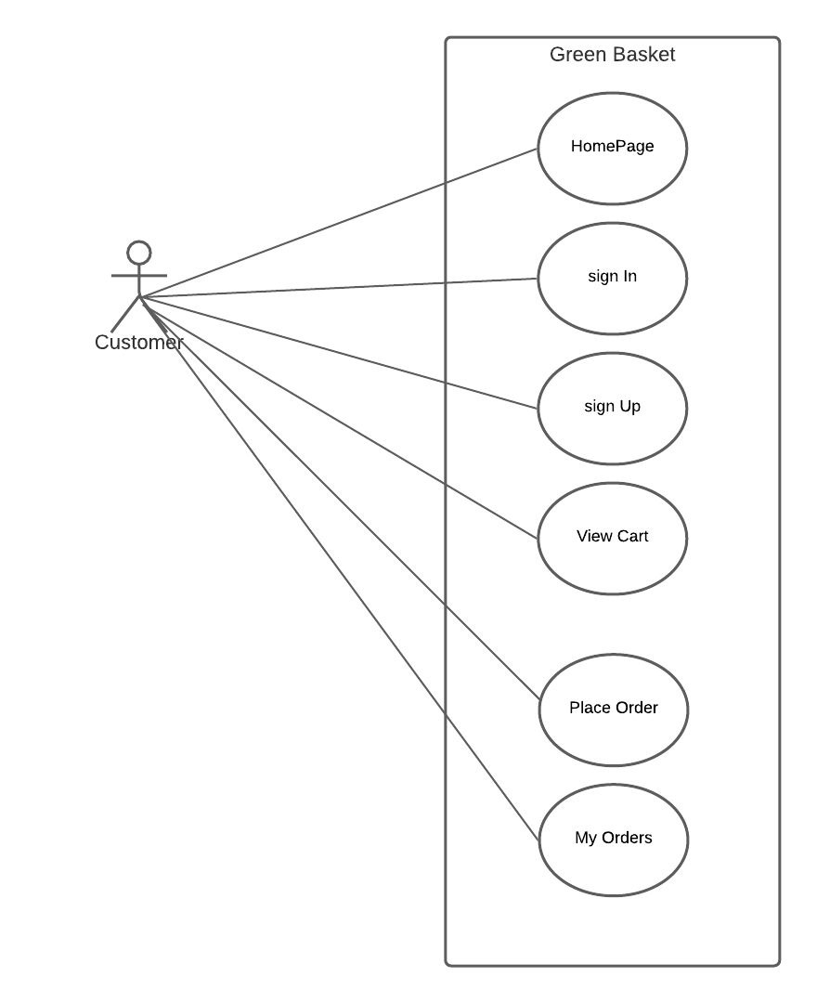

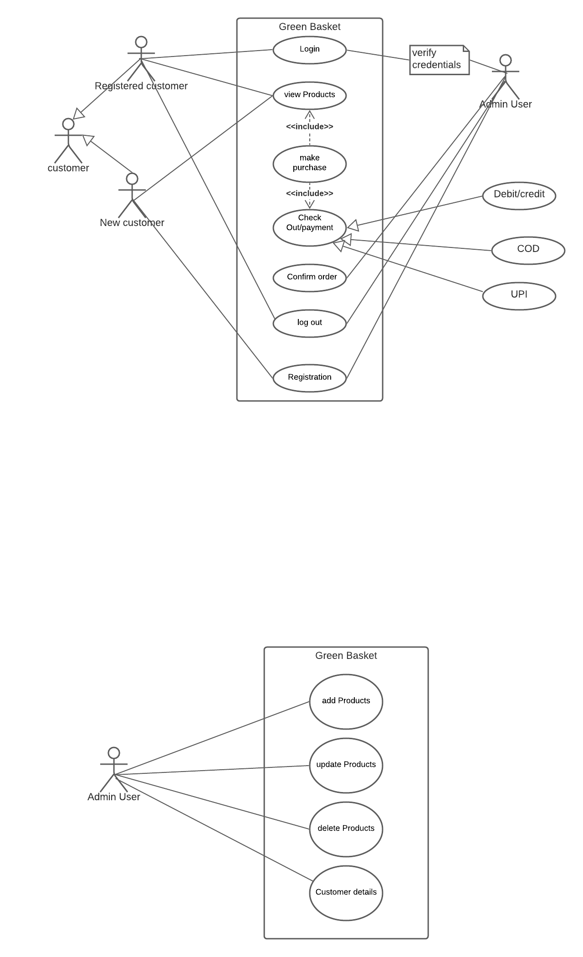

**4.1 USER INTERFACE REQUIREMENTS**

**Login Page:**

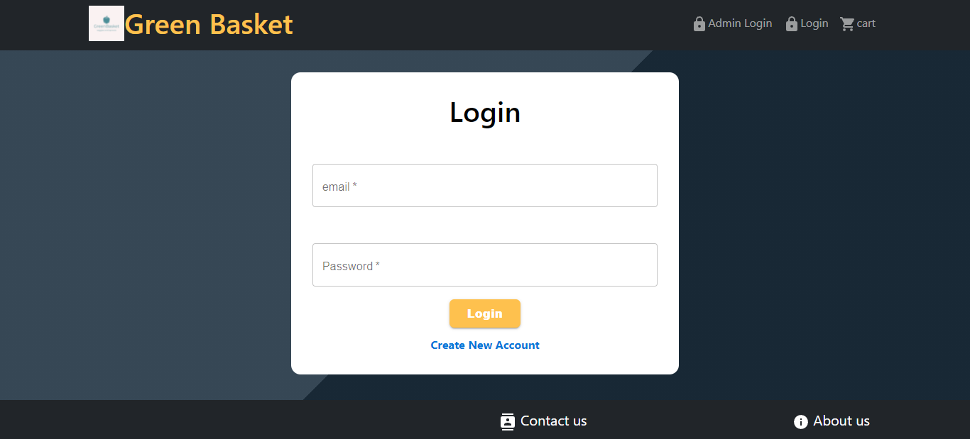

**Sign Up Page:**

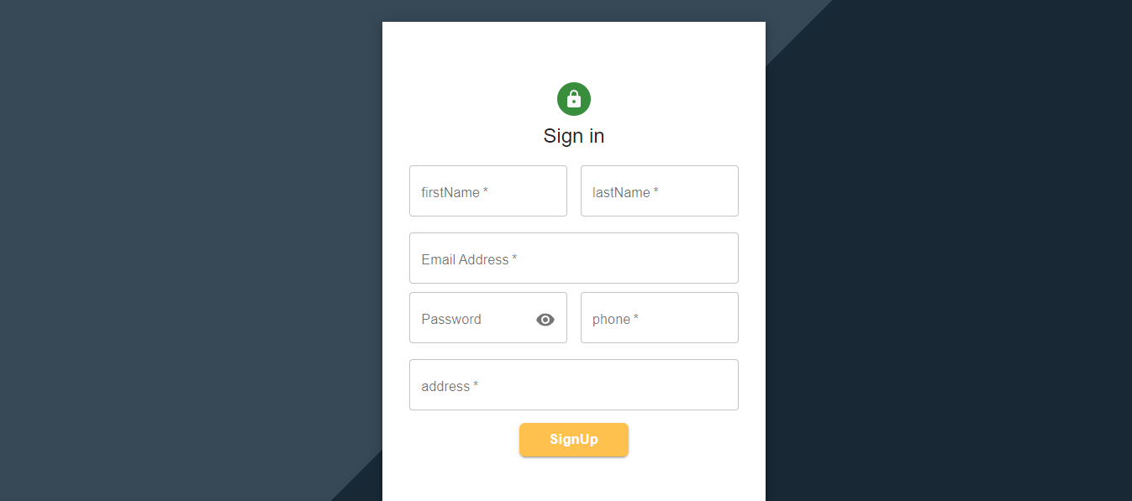

**Home Page**

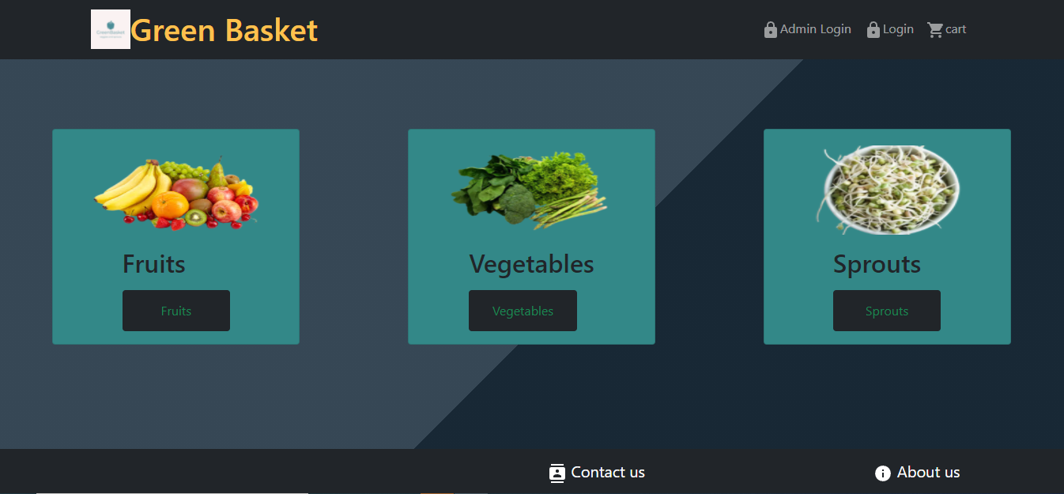

**Categories:**

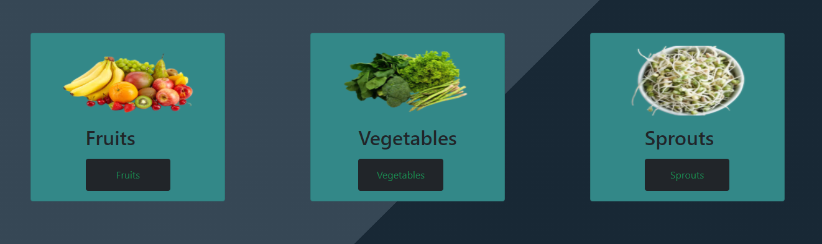

**Fruit Category page:**

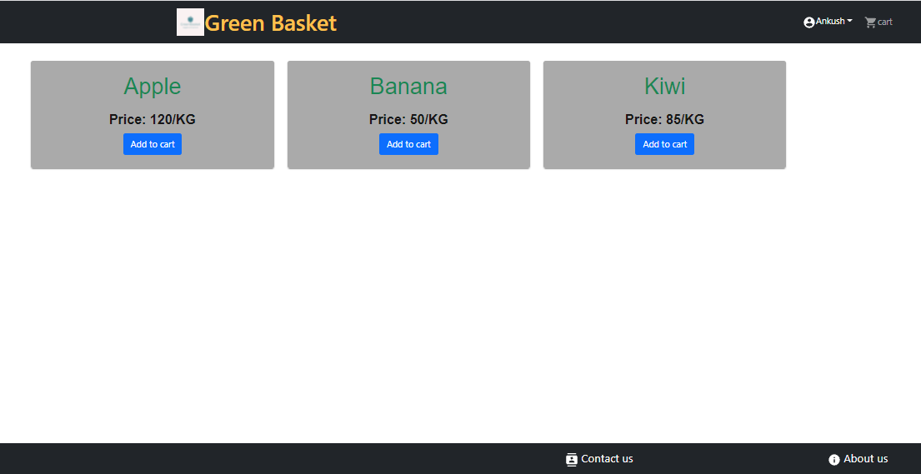

**Vegetables Category Page:**

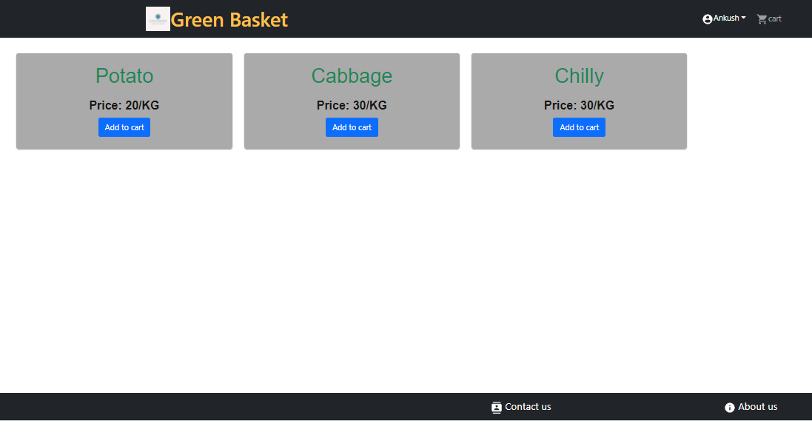

**Sprouts Category page:**

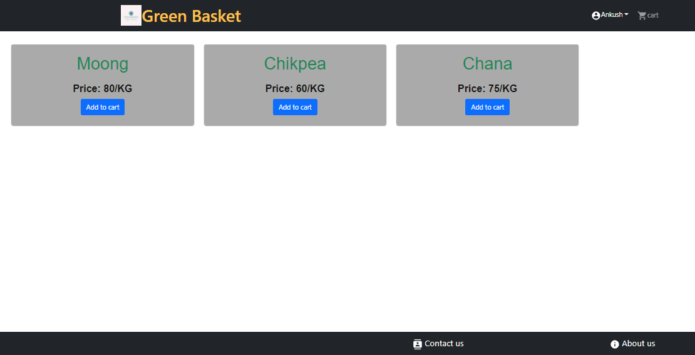

**All Product Page:**

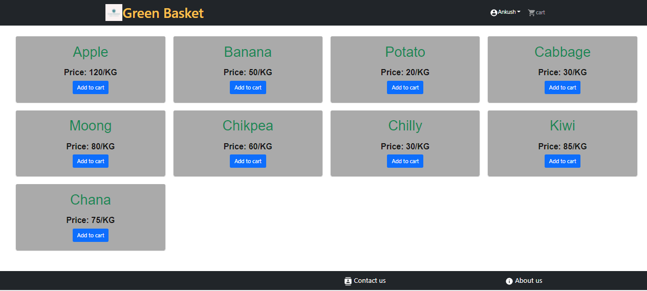

**Admin UI Page:**

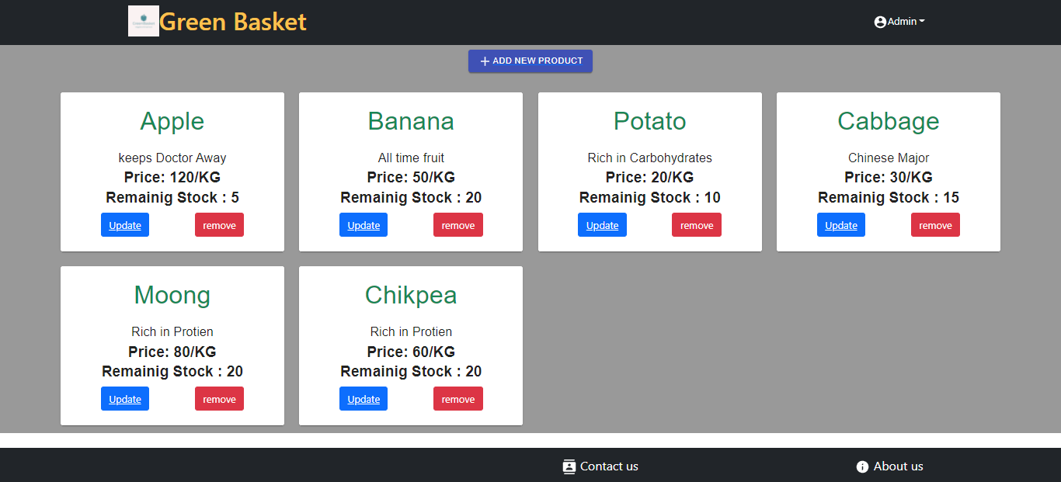

**Admin View All Customer Details:**

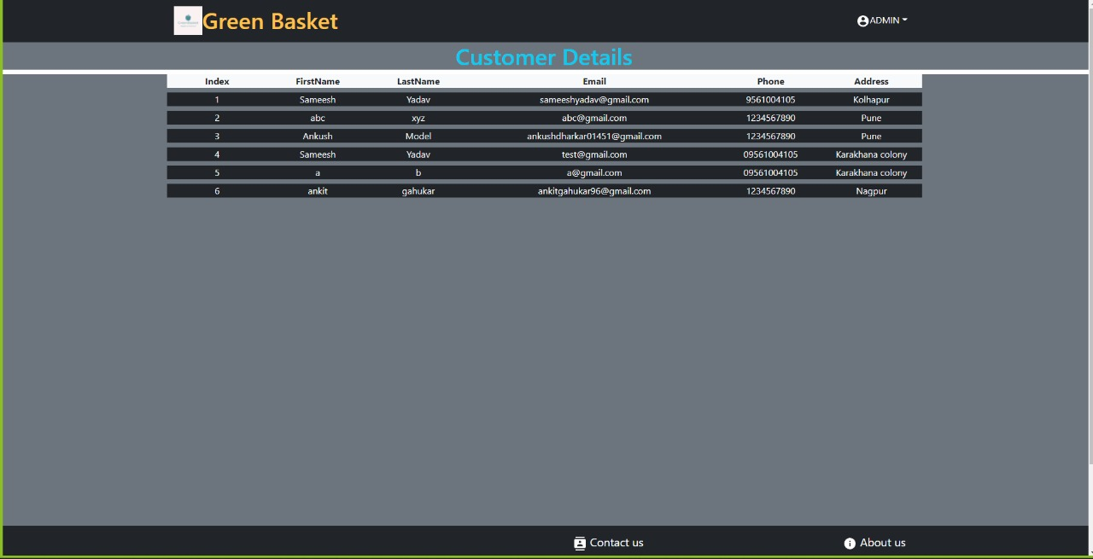

**Update Product:**

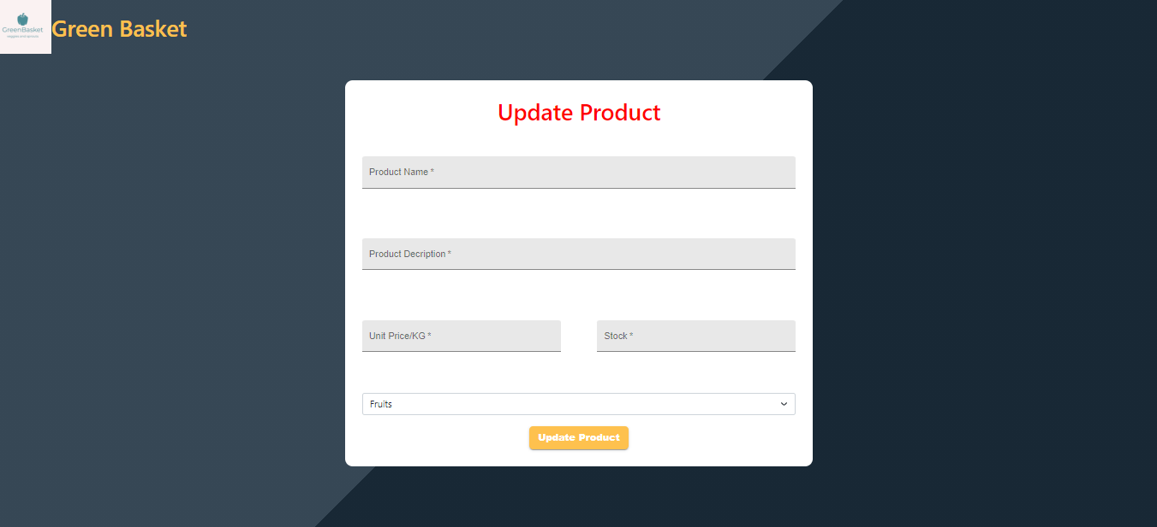

**Add Product Page:**

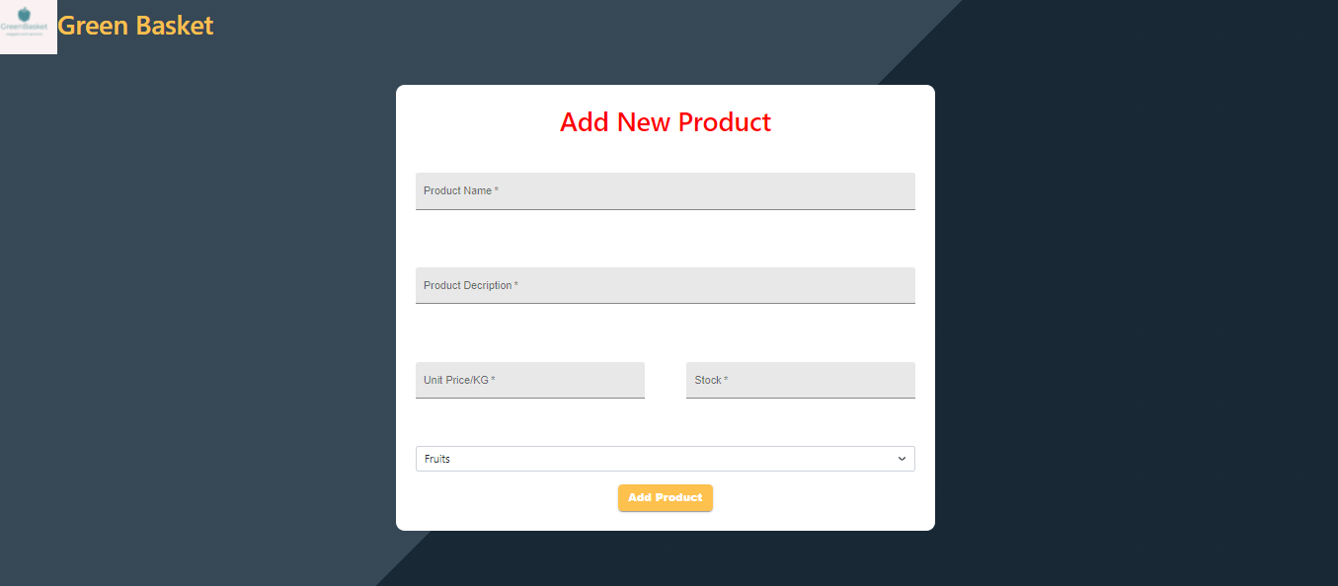

Check Out Page:

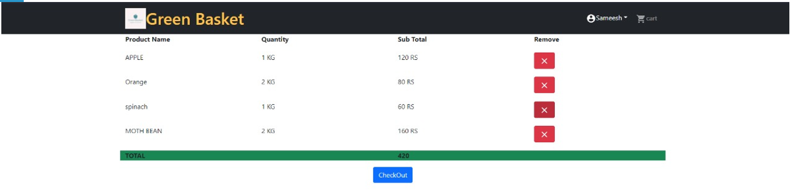

Order Placed Pop up:

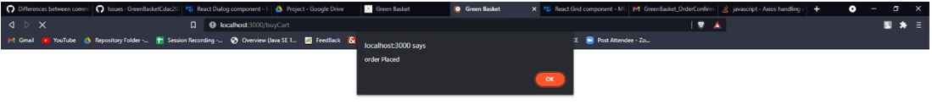

Order Confirmation Email:

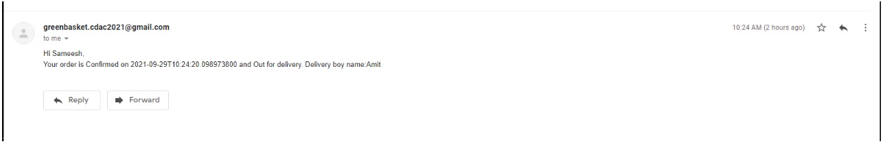

Contact Page

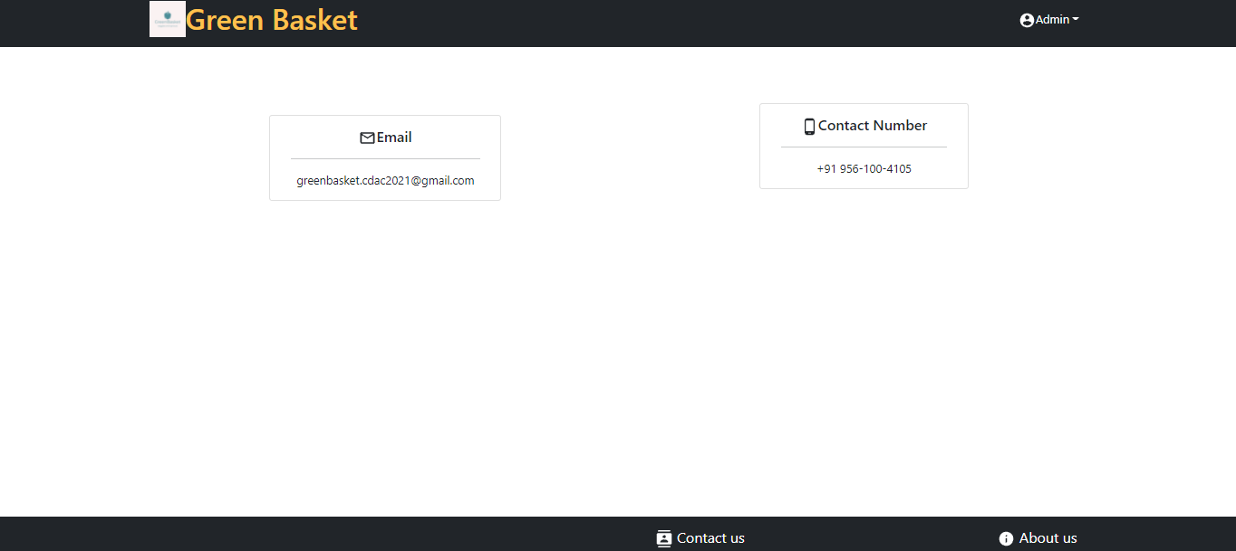

**About Us:**

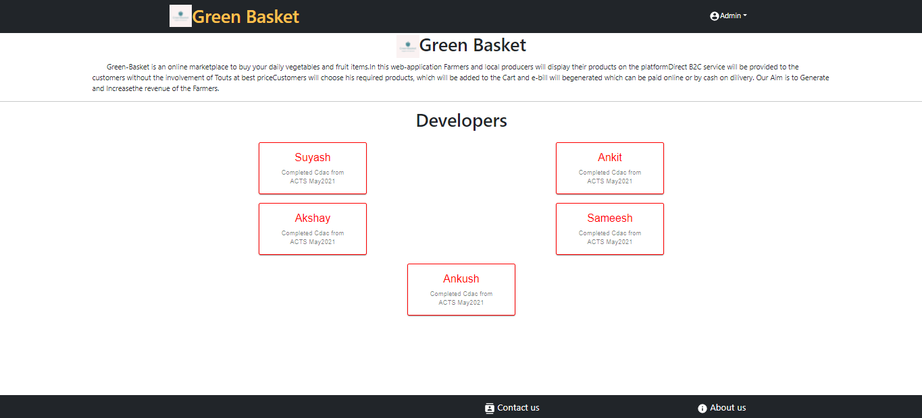

**5.2 Database Design**

The following table structures depict the database design.

### ER Diagram

### C:\Users\Hp\Downloads\WhatsApp Image 2021-09-27 at 6.44.40 PM.jpeg

1. **Testing:**

**The report of the testing is given here under.**

**Test Cases**

|  |  |  |  |  |  |
| --- | --- | --- | --- | --- | --- |
| **Sr.**  **No** | **Test Case**  **Title** | **Description** | **Expected**  **Outcome** | **Error**  **Message** | **Result** |
| 1 | Login Page | User/customer should see login page when user will enter email and password. | After signing in user to be directed to home page | Invalid Credentials | Passed |
| 2 | Home page  Displayed | Home page display for every  successful log in. | Home Page  Displayed | No Error | Passed |
| 3 | Categories Page | Users/customer can see different categories of the  products available. | Category to be selected. | No Error | Passed |
| 4 | My Orders Page | Here, user can see his all its order and can also cancel the order. | User can manage is order. | Order Not Found | Passed |
| 5 | Contact Us | User can contact to the company. | User can write his problem to the company. | No Error | Passed |
| 6 | Checkout Page | User can review its product details. | After clicking on checkout user will place the order. | Placing Order Failed | Passed |
| 7 | Sign Up | Should not allow any control to be empty if not null | If validated  Allow to go to home page | User Already Existed | Passed |
| 8 | Cart | User should be able to see its product details. | All product added to the cart be  seen. | Cart Not Found | Passed |
| 9 | Sign Out | User should be able to logout from the website | User will logout and will be redirected to the Sign In page. | No Error | Passed |
| 10 | Admin Adds  Product | Admin should be able to add new product as per categories | Product will be added in the respective categories | Product Already Existed | Passed |
| 11 | Admin Update Product | Admin should able to update existing product as per categories | Product Quantity will be Updated | Product Not Found | Passed |

1. **Project Management Methodology:**

Scrum Agile Methodology was used.

### FUTURE SCOPE :

* 1. We will provide payment gateway to the user so that he can also pay through online mode.
  2. We will be adding more Functionalities to the website so that it will give more options to the customer to select their favorite products.
  3. Order tracking functionality to the Customer.